PrimUS Bank
ADMIN Module
Functional Requirements
Version 2.0

Document Name | Version Number | Start Date | Prepared By | Reviewed By | Modified Date | Present Status
PrimusBank_Admin_FRS | 2.0 | 18/01/2012 | QEdge Team | Suresh Babu | 26/01/2012 | Completed

1.0 Primus Bank Home Page

Overview
PRIMUS Home page allows different users such as admin, bank employee, various customers (Individual customers, corporate customers, International Customers) to login and access the application for further usage and also it provides information about various services offered by PRIMUS Bank.

1.1.1 Prototype

PRIMUS Home Page
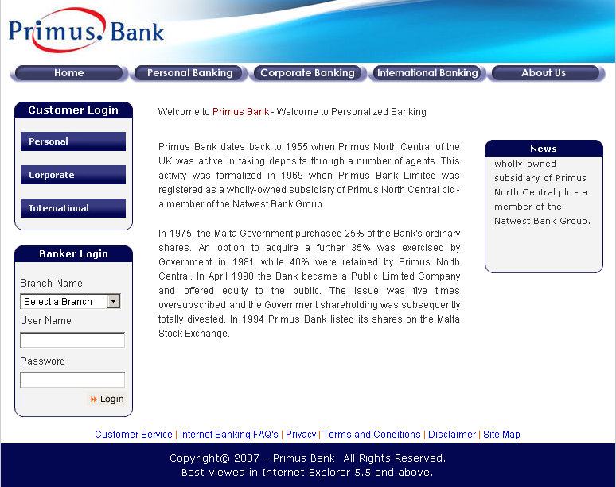

1.4.2 Admin Login Admin
Enters valid User Name and Password
Login
System displays Home page of Primus Bank

System displays Admin module.

Enters valid URL

Clicks

1.5.0 Use Cases

1.5.2 Admin Process flow in Home Page
Actors Action | System Response
1. Actor Enters Valid URL | 1. System displays home page with login facility.
2. Actor enters valid user name | 2.. System will accept
3. Actor enters valid password | 3. System will accept.
4. Actor clicks Login | 4. System displays Admin module.

2.0 Admin Home Page

2.1.0 Overview
This page allows administrator to define and manage master data such as Branches, Roles, Users and Employees related to PRIMUS Bank.

2.1.1 Prototype

Admin Home Page

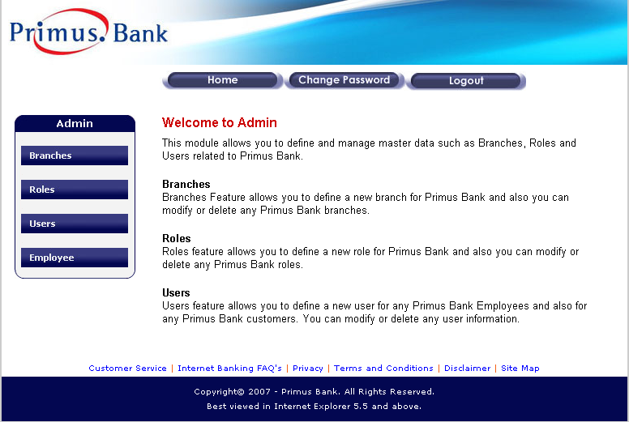

2.1.2 Page Elements
Element Name | Element Type | User Action | System  Response
Branches | Button | Click | As per task flow diagram
Roles | Button | Click | As per task flow diagram
Users | Button | Click | As per task flow diagram
Employees | Button | Click | As per task flow diagram
Home | Button | Click | As per task flow diagram
Change Password | Button | Click | As per task flow diagram
Logout | Button | Click | As per task flow diagram

2.1.3 Input Validations & Error States
NA
2.1.4 Admin Home Page Task flow diagram
Branches
Change Password
Roles
Users
Employees
Home
Logout
System displays Branches details Page
System displays Roles details Page.
Page
System displays Users details Page.

System displays Employees Details Page.

System displays Home page of Admin module.

System displays Change Password Page.

Logout from the system and displays Primus Home Page.

2.1.5 Use Cases
Actors Action | System Response
1. Actor clicks Branches | 1. System displays Branches details page.
2. Actor clicks Roles | 2. System displays Roles details page
3. Actor clicks Users | 3. System displays User details page.
4. Actor clicks Employees | 4. System displays Employees details page.
5. Actor clicks Home | 5. System displays Admin Home Page
6. Actor clicks Change Password | 6. System displays Change Password page.
7. Actor clicks Logout | 7. Current session will be closed and system displays PRIMUS Home Page.

3.0 Branches

3.1 Branches Details

3.1.0 Overview
Branches Feature allows admin to define a new branch, modify or delete any PRIMUS Bank branches and also admin can search for branches information based on the given selection criteria.

3.1.1 Prototype
v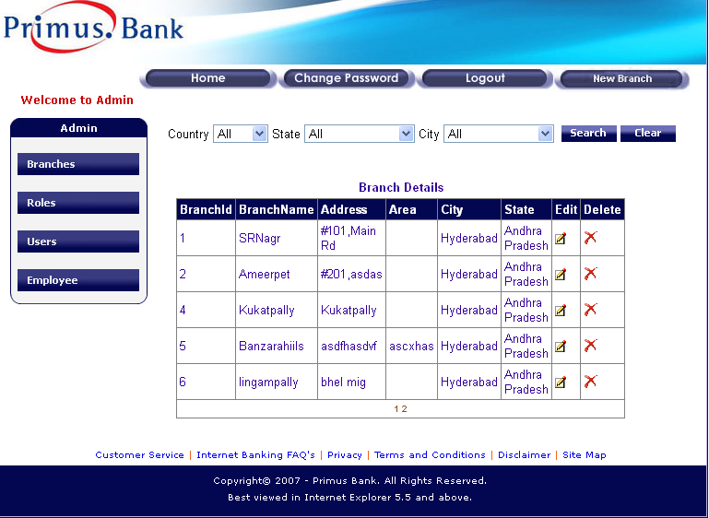

3.1.2 Page Elements
Element Name | Element Type | User Action | System  Response
Country | List box | Select | As per use cases.
State | List box | Select | As per use cases.
City | List box | Select | As per use cases.
Search | Button | Click | As per use cases
Clear | Button | Click | As per use cases
New Branch | Button | Click | As per task flow diagram

Branches Details Table
Branch Id | Tab. element | NA | NA
Branch Name | Tab. element | NA | NA
Address | Tab. element | NA | NA
Area | Tab. element | NA | NA
City | Tab. element | NA | NA
State | Tab. element | NA | NA
Edit | Image Link | Click | As per task flow diagram
Delete | Image Link | Click | As per task flow diagram

3.1.3 Input Validations & Error States

NA

3.1.4 Task flow diagram for Search and clear
Selects State
Selects Country
Selects City
Click on Search
Click on Clear
System displays Country’s with in selected Country in Country List box

System displays states with in selected Country in State List box

System displays Cities with in selected State in City List box

System displays branches based on the selection criteria.

System Clears selected criteria displays all branches.

3.1.5 Admin flow for Search and Clear.
Actors Action | System Response
1. Actor login | 1.System displays Admin module
2. Actor clicks Branches | 2. System displays branches details page.
3. Actor selects required criteria of Country/State/City and clicks Search. | 3. System displays only the branches matching the selected criteria.
4. Actor clicks Clear. | 4. System clears the given search criteria and all branches will be displayed.

3.2 New Branch Creation

3.2.0 Overview

This feature allows Admin to create a new branch for PRIMUS Bank.

3.2.1 Prototype 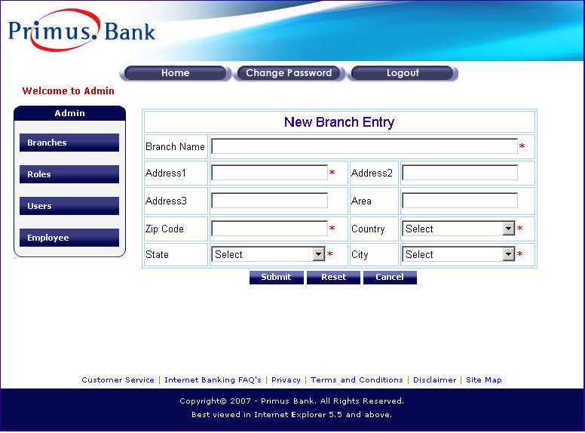

3.2.2 Page Elements

Element Name | Element Type | User Action | System  Response
Branch Name | Text box | Enter/Edit | As per task flow diagram
Address1 | Text box | Enter/Edit | System should accept
Address2 | Text box | Enter/Edit | System should accept
Address3 | Text box | Enter/Edit | System should accept
Area | Text box | Enter/Edit | System should accept
Zip code | Text box | Enter/Edit | System should accept
Country | List box | Select | As per Use cases
State | List box | Select | As per Use cases
City | List box | Select | As per Use cases
Submit | Button | Click | As per task flow diagram
Reset | Button | Click | As per task flow diagram
Cancel | Button | Click | As per task flow diagram

3.2.3 Input Validations & Error States
Element Name | Valid Data | Error state
Branch Name | - Alphanumeric only  - Start with alphabet  - Min of 6 Chars  - Max of 40 Chars  - Mandatory  - Unique | - Blank – “Please fill in the following fields – Branch Name”  - Invalid Chars- “This field should be alphanumeric starts with an alphabet”  - Invalid Range- “This field should be with in 6 - 40 chars range.  - Duplicate- “ This branch already exists”
Address1 | 1. Alphanumeric and special Chars.  2.Mandatory  3. Min of 4 chars.  4. Max of 50 chars. | - Blank – “Please fill in the following fields – Address1”  - Invalid Range- “This field should be with in 4 - 50 chars range.
Address2 | 1. Alphanumeric and special Chars.  2. Max of 50 Chars. | - Invalid Length- “This field accepts a maximum of 50 Chars.
Address3 | 1. Alphanumeric and special Chars.  2. Max of 50 Chars. | - Invalid Length- “This field accepts a maximum of 50 Chars.
Area | 1. Alphanumeric and special Chars.  2. Should start with alphabet.  3. Max of 50 Chars. | - Invalid Length- “This field accepts a maximum of 50 Chars.
Zip | 1. Numeric Only  2. It should be 5 numeric’s  3. Mandatory | - Blank – “Please fill in the following fields – Zip”  - Invalid Chars- “This field should be numeric”  - Invalid Range- “It should be 5 chars in length”
Country | 1. Mandatory | - Blank – “Please fill in the following fields – Country”
State | 1. Mandatory | - Blank – “Please fill in the following fields – State”
City | 1. Mandatory | - Blank – “Please fill in the following fields – City”

    - New Branch Creation
Actor
Yes
No
Login
Branches
Click New Branch
Enter Branch Details
Click Submit
New Branch will be created successfully
created
Ask for valid data
Click Reset
All the data is cleared
Click Cancel
Close the page
Ok
If valid

3.2.5 Use Cases

Admin flow for Addition of New Branch.
Actors Action | System Response
1. Actor login | 2.System displays Admin module
3. Actor select Branches | 4. System displays branches details page.
5. Actor click New Branch | 6. System displays New branch Entry Page.
7. Actor Enters necessary fields with valid data and clicks Submit. | 8. 1.Fill all fie
9. Actor enters necessary fields with valid data and clicks Reset. | 10. System clears all fields.
11. actor enters necessary fields with valid data or with out entering any fields clicks Cancel. | 12. System closes the new branch entry page and displays branches details page.

3.3 Branch Updation

3.3.0 Overview

This feature allows Admin to modify the details of a PRIMUS branch.

3.3.1 Prototype
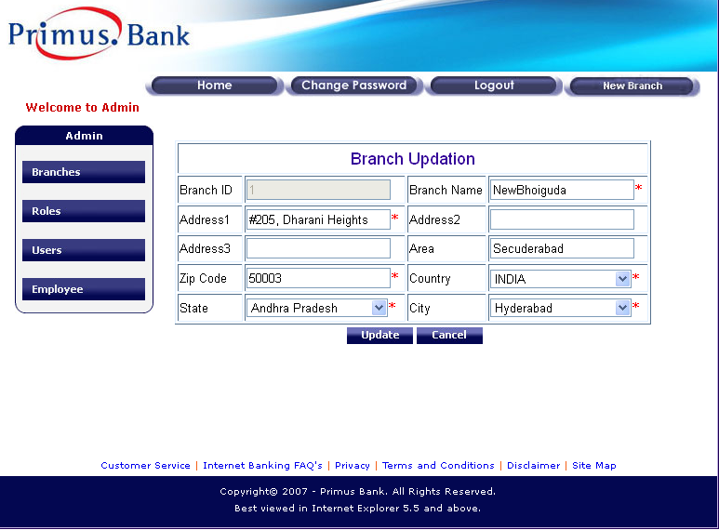

3.3.2 Page Elements
Element Name | Element Type | User Action | System  Response
Branch Id | Auto Display | NA | NA
Branch Name | Text box | Enter/Edit | As per task flow diagram
Address1 | Text box | Enter/Edit | System should accept
Address2 | Text box | Enter/Edit | System should accept
Address3 | Text box | Enter/Edit | System should accept
Area | Text box | Enter/Edit | System should accept
Zip code | Text box | Enter/Edit | System should accept
Country | List box | Select | As per Use cases
State | List box | Select | As per Use cases
City | List box | Select | As per Use cases
Update | Button | Click | As per task flow diagram
Cancel | Button | Click | As per task flow diagram

3.3.3 Input Validations & Error States
Refer 3.2.3

3.3.4 Branch Update
Yes
No
Ask for missing /valid data
OK
If modified data is Valid
Login
Branches
Select required Branch record
Update Branch Details
Click Update
Branch details will be updated successfully
Click Cancel
The page will be closed
Actor

3.3.5 Use Cases

Admin flow for modification of Branch.
Actors Action | System Response
1. Actor login | 2.System displays Admin module
3. Actor select Branches | 4. System displays branches details page.
5. Actor click edit for any branch | 6. System displays branch updating page.
7. Actor modifies necessary fields with valid data and clicks Update. | 8. System displays a message “New Branch Updated successfully”
9. Actor modifies necessary fields with valid data or with out modifying any fields clicks Cancel. | 12. System closes the branch updating page and displays branches details page.

Branch Deletion

3.4.0 Overview
This feature is useful for Admin to delete an unwanted PRIMUS branch
.

Branch Delete
Actor
OK
Cancel
Login
Branches
Select required Branch record
Click Delete
Select ok or cancel to confirm
If
If Dependencies
Records are shared, Cannot be deleted

Record will be deleted
Branch details page

Yes No

    - Use Cases

Admin flow for Deletion of Branch.
Actors Action | System Response
1. Actor login | 1.System displays Admin module
2. Actor select Branches | 2. System displays branches details page.
3. Actor click Delete for any branch | 3. System displays a confirmation “Are you sure you want to delete this record?” with “Ok” and “Cancel” buttons.
4. Actor click “ok” button | 4.1 System Deletes Selected Branch (if there is no dependency) and displays ”Branch Deleted Successfully” message  4.2 If dependency exists, system will not allow to delete and displays a message “its a shared record cannot be deleted”
5. Actor clicks Cancel. | 5. System closes the branch Deletion page and displays branches details page.

4.0 Roles

4.1 Roles Details Page

Overview

This Page displays all existing roles and allows admin to create a new Role, modify and delete a Role

Prototype
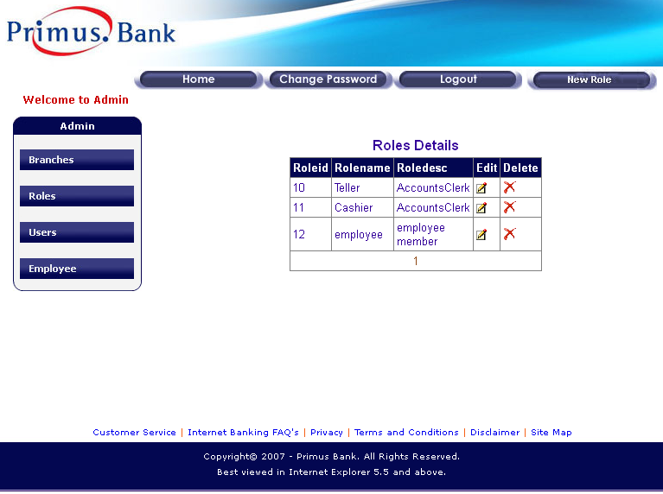

Page Elements
Element Name | Element Type | User Action | System  Response
Roles Details Table
Role Id | Tab. element | NA | NA
Role Name | Tab. element | NA | NA
Role Description | Tab. element | NA | NA
Edit | Image link | Click | As per Task flow Diagram
Delete | Image Link | Click | As per Task flow Diagram
New Role | Button | Click | As per Task flow Diagram

New Role Creation.

Overview

This feature allows admin to create a New Role.

Prototype

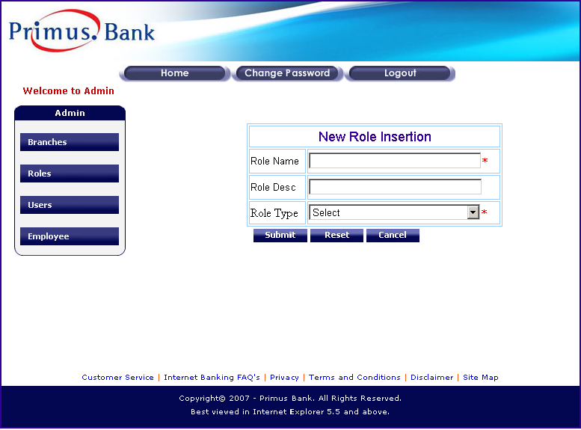

Page Elements
Element Name | Element Type | User Action | System  Response
Role Name | Text box | Enter/Edit | System should Accept
Role Description | Text box | Enter/Edit | System should Accept
Role Type | List box | Select | System should display the selected Role type.
Submit | Button | Click | As per task flow diagram
Reset | Button | Click | As per task flow diagram
Cancel | Button | Click | As per task flow diagram

    - Input Validations & Error States
Element Name | Valid Data | Error state
Role Name | - Mandatory  - Alphabets Only.  3. Min of 4 Chars Max of 30 Chars  4. Unique | 1.Blank – “Please fill in the following fields – Role Name”  2.Invalid Chars- “This field shou ld be alphabets only”  3.Invalid Range- “It should be with in 4 – 30 chars in length”  4.Duplicate-“This Role already exists”
Role Description | 1. Alphanumeric and special Chars.  2. Max of 50 chars. | 1.Invalid Range- “This  Field should be max of 50 chars.
RoleType | 1. Mandatory | 1.Blank – “Please fill in the following fields – Role type”

    - New Role Creation
Ok
Login
Roles
Select new Role in roles details page
Click new role and Enter role details
Click Submit
Click Reset
All the data is cleared
Click Cancel
Close the page
Ask for valid role details
If valid
New Role will be created

    - Use Cases

Admin flow for Addition of New Role.
Actors Action | System Response
1. Actor login | 1.System displays Admin module
2. Actor select Roles | 2. System displays Roles details page.
3. Actor click New Roles | 3. System displays New Role Entry Page.
4. Enter necessary fields with valid data and clicks Submit. | 4. System displays a message “New Role Created successfully with Role Id”
5. Enters necessary fields with valid data and clicks Reset. | 5. System clears all fields.
6. Enters necessary fields with valid data or with out entering any fields clicks Cancel. | 6. System closes the new role entry page and displays roles details page.

Role Updation

Overview

This feature allows admin to modify an existing Role.

Prototype
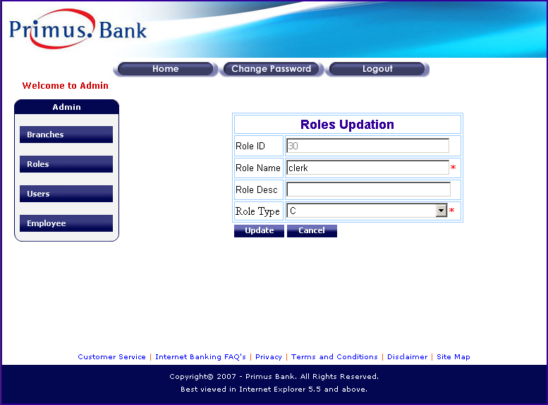

4.3.3 Page Elements
Element Name | Element Type | User Action |  | System  Response
Role Id | Auto Display | NA | NA
Role Name | Text box | Enter/Edit | System should Accept
Role Description | Text box | Enter/Edit | System should Accept
Role Type | List box | Select | System should display the selected Role type.
Update | Button | Click | As per task flow diagram
Cancel | Button | Click | As per task flow diagram

4.3.4 Input Validations & Error States

Refer 4.2.4

    - Role Update
Login
Roles
Select Requited Role in Details page
Click Edit and update details
Click Update
Role details will be updated successfully
Ask for missing /valid data
Click Cancel
The page will be closed
Ok
If modified data is Valid

Actor

No
Yes

    - Use Cases

Admin flow for Edit of Existing Role Information.
Actors Action | System Response
1. Actor login | 2.System displays Admin module
3. Actor select Roles | 4. System displays Roles details page.
5. Actor click edit on the respective role to be edited | 6. System displays Roles Update Page.
7. Update necessary fields with valid data and clicks Update. | 8. System displays a message “Roles Updated Successfully”
9. Update necessary fields with valid data or with out entering any fields clicks Cancel. | 10. System closes the Update role page and displays roles details page.

4. 4.0 Role Deletion

4.4.1 Overview

This feature allows admin to delete an unwanted role.

4.4.2 Role Delete
OK
Cancel
Login
Roles
Select Required Role record
Click Delete
Select ok or cancel to confirm
If
If Dependencies
Records are shared, Cannot be deleted
Record will be deleted

Actor

Yes No

4.4.3 Use Cases

Admin flow for Deletion of Existing Role.
Actors Action | System Response
1. Actor login | 2.System displays Admin module
3. Actor select Roles | 4. System displays Roles details page.
5. Actor click Delete on the respective role to be deleted. | 6. System displays a message “Are you sure you want to delete this record”
7. Actor Click Ok | 8. System displays a message “Deletion Successful”
9. Actor Click cancel | 10.System stops the process

5.0 Users

5.1 Users Details Page.

5.1.1 Overview

This page displays all users’ information and also allows admin to define and manage PRIMUS bank users.

5.1.2 Prototype
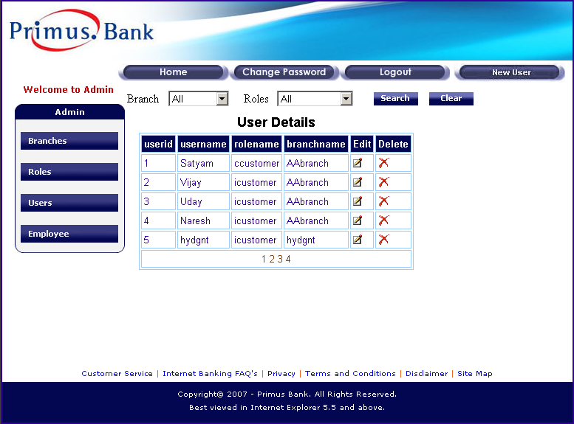

5.1.3 Page Elements
Element Name | Element Type | User Action | System  Response
Branch | List box | Select | As per use cases.
Roles | List box | Select | As per use cases.
Search | Button | Click | As per Task flow Diagram
Clear | Button | Click | As per Task flow Diagram
New User | Button | Click | As per task flow diagram
Users Details Table
User Id | Tab. Element | NA | NA
User Name | Tab. Element | NA | NA
Role Name | Tab. Element | NA | NA
Branch name | Tab. Element | NA | NA
Edit | Image Link | Click | As per task flow diagram
Delete | Image Link | Click | As per task flow diagram

5.1.3 User Search

Selects Role
Selects Branch
Click on Search
Click on Clear
System displays list of branches in branch List box

System displays list of roles in roles List box

System displays user record based on the selection criteria.

System Clears selected criteria displays all users records

5.2 New User Creation

5.2.1 Overview

This feature allows admin to create a new user for PRIMUS Bank. The new user id is created for the existing customers. To create new user any customer should exist.

5.2.2 Prototype
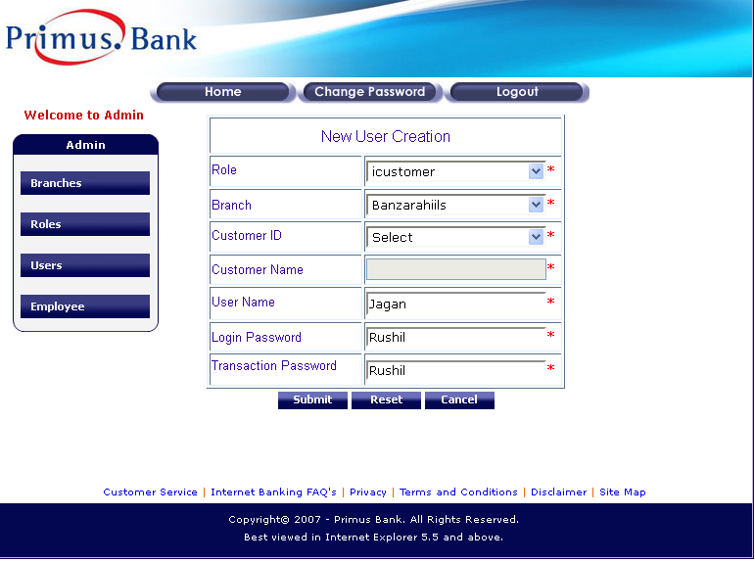

5.2.3 Page Elements
Element Name | Element Type | User Action | System  Response
User Name | Text box | Enter/ Edit | System should accept
Login Password | Text box | Enter/ Edit | System should accept
Transaction Password | Text box | Enter/ Edit | System should accept
Branch | List box | Select | Should display the selected branch
Role | List box | Select | Should display the selected role.
Customer Id | List box | Select | Should display Customer ID’s depending on selection of Role And branch.
Customer Name | Text Box | Auto Display | System displays customer name for the selected customer Id
Submit | Button | Click | As per task flow Diagram.
Reset | Button | Click | As per task flow Diagram.
Cancel | Button | Click | As per task flow Diagram.

5.2.4 input Validations
Element Name | Valid Data | Error state
User Name | 1. Alphanumeric only.  2. Start with an Alphabet.  3. Min of 4 Chars.  4. Max of 16 Chars.  5. Mandatory.  6. Unique | 1. Blank - “Please fill in the following fields – User Name”  2.Invalid Chars- “This field should be alphanumeric only”  3.Invalid Range- “It should be with in 4 - 16 chars in length”
Login Password | 1. Alphanumeric and  Special Chars.  2. Min of 4 Chars.  3. Max of 16 Chars.  4. Mandatory. | 1. Blank - “Please fill in the following fields – Login Password”  2.Invalid Range- “It should be with in 4 - 16 chars in length”
Transaction Password | 1. Alphanumeric and  Special Chars.  2. Min of 4 Chars.  3. Max of 16 Chars.  4. Mandatory. | 1. Blank - “Please fill in the following fields – Transaction Password”  2.Invalid Range- “It should be with in 4 - 16 chars in length”
RoleType | 1. Mandatory | 1. Blank – “Please fill in the following fields – Role type”
Branch | 1. Mandatory | 1. Blank – “Please fill in the following fields – Branch Name”
Customer ID | 1.Mandatory | 1. Blank – “Please fill in the following fields – Customer ID”
Customer Name | 1.Mandatory  2.Read only | 1. Blank – “Please fill in the following fields – Customer Name”

5.2.5 New User Creation
Yes
No
Click Cancel
Close the page
Ok
Click Submit
Click Reset
Login
Users
Select new user in details page
Click new User and Enter user’s details
Ask for valid User details
All the data will be cleared
If valid
New User will be created

Actor

5.2.6 Use Cases

Admin flow for Creation of New User.
Actors Action | System Response
1. Actor login | 2.System displays Admin module
3. Actor select Users | 4. System displays user details page.
5. Actor click New user | 6. System displays New user creation Page.
7. Actor Enters necessary fields with valid data and clicks Submit. | 8.System displays a message “New User Created successfully with User ID”
9. Actor enters necessary fields with valid data and clicks Reset. | 10. System clears all fields.
11. actor enters necessary fields with valid data or with out entering any fields clicks Cancel. | 12. System closes the new user creation page and displays user details page.

5.3 User Updation

5.3.1 Overview

This feature allows admin to modify existing user information.

5.3.2 Prototype
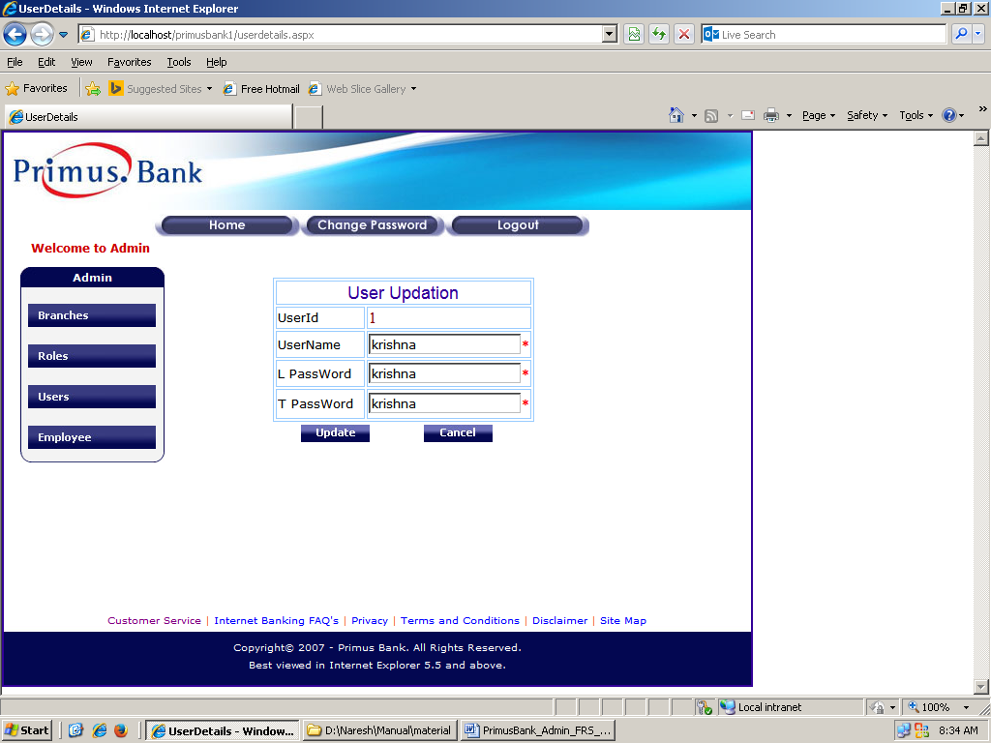

5.3.3 Page Elements
Element Name | Element Type | User Action | System  Response
User Id | Auto display | NA | NA
User Name | Text box | Enter/ Edit | System should accept
Login Password | Text box | Enter/ Edit | System should accept
Transaction Password | Text box | Enter/ Edit | System should accept
Update | Button | Click | As per task flow Diagram.
Cancel | Button | Click | As per task flow Diagram.
5.3.4 Input Validations & Error States

Refer 5.2.4

5.3.5 User Updation
Actor
No
Yes
Login
Users
Select required User in the list
Click Edit and update details
Click Update
User details will be updated
Ask for missing valid data
Click Cancel
The page will be close
Ok
If modified data is Valid

5.3.6 Use Cases

Admin flow for modification of User.

Actors Action | System Response
1. Actor login | 1.System displays Admin module
2. Actor select Users | 2. System displays user’s details page.
3. Actor click edit for any user | 3. System displays user updation page.
4. Actor modifies necessary fields with valid data and clicks Update. | 4. System displays a message “User Updated successfully”
5. Actor modifies necessary fields with valid data or with out modifying any fields clicks Cancel. | 5. System closes the user updation page and displays user details page.

5.4 User Deletion

5.4.1 Overview

This feature allows admin to delete an unwanted PRIMUS bank user.

5.4.2 User Deletion
Actor
Ok
Cancel
Login
Users
Select required User in the list
Click Delete
Select Ok or Cancel
To Conform

The user record will be deleted
The user cannot be deleted
If

5.4.3 Use Cases

Admin flow for Deletion of a User.
Actors Action | System Response
1. Actor login | 1.System displays Admin module
2. Actor select Users | 2. System displays user’s details page.
3. Actor click Delete for any user | 3. System displays a confirmation window with “Yes” and “No” options.
4. If Actor clicks “Ok” | 4. System deletes the user.
5. If actor clicks “Cancel” | 5. System displays User details page.

6. Employees

6.1 Employee Details Page

6.1.0 Overview

This feature allows admin to view login user names of PRIMUS bank employees working with various branches and to define and manage logins for employees.

6.1.1 Prototype
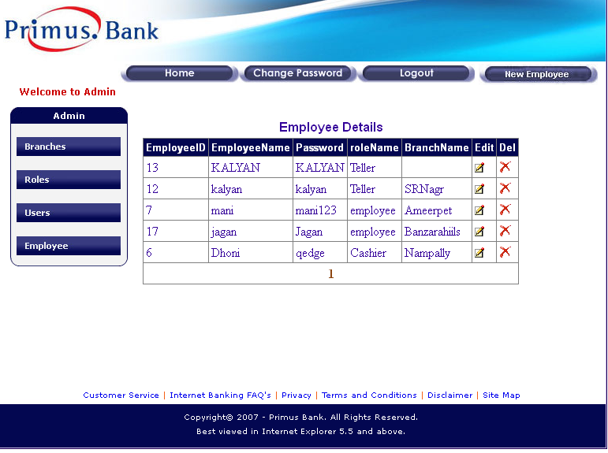

6.1.2 Page Elements

Element Name | Element Type | User Action | System  Response
Employee Id | Tab. Element | NA | NA
Employee Name | Tab. Element | NA | NA
Password | Tab. Element | NA | NA
Role | Tab. Element | NA | NA
Branch | Tab. Element | NA | NA
Edit | Button | Click | AS per task flow diagram
Delete | Button | Click | AS per task flow diagram
New Employee | Button | Click | AS per task flow diagram

6.2 New Employee Creation

6.2.1 Overview

This feature allows admin to create a new login for PRIMUS Bank branch employee.

6.2.2 Prototype.
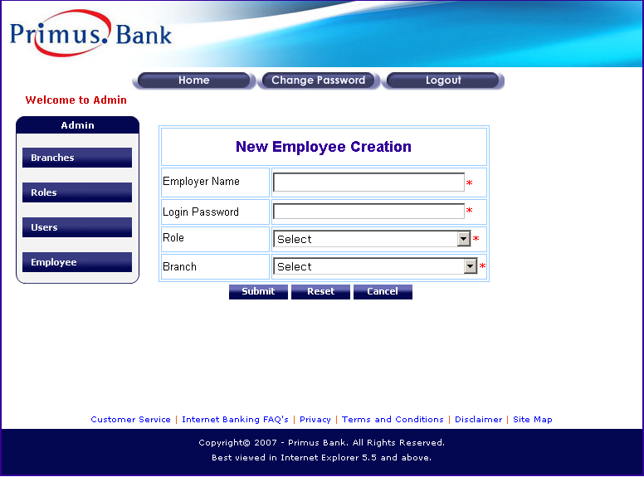

6.2.3 Page Elements
Element Name | Element Type | User Action | System  Response
Banker Name | Text box | Enter/Edit | Accepts
Login Password | Text box | Enter/Edit | Accepts
Role | List box | Select | Displays selected role
Branch | List box | Select | Displays selected role
Submit | Button | Click | As per task flow diagram
Reset | Button | Click | As per task flow diagram
Cancel | Button | Click | As per task flow diagram

6.2.4 Input Validations
Element Name | Valid Data | Error state
Banker Name | 1. Alphanumeric only.  2. Start with an Alphabet.  3. Min of 4 Chars.  4. Max of 16 Chars.  5. Mandatory.  6. Unique | - Blank/Invalid- “Enter a Valid Banker  Name”
Login Password | 1.Alphanumeric and  Special Chars.  2. Min of 4 Chars.  Max of 16 Chars.  3. Mandatory. | - Blank/Invalid- “Enter valid password”
Role | 1. Mandatory | 1. Blank- “Select a Valid Role”
Branch | 1. Mandatory | 1. Blank- “Select a Valid branch”
6.2.5 New Employee Creation
Actor
Click Cancel
Ok
Click Submit
Login
Employee
Click New Employee
Enter Employee Details like role, branch
Ask for valid User details
All the data will be cleared
If valid
New Emp will be created
No
Click Reset
Close the page
Yes

Yes

6.2.6 Use Cases
Admin flow for Addition of New Employee.
Actors Action | System Response
1. Actor login | 2.System displays Admin module
2. Actor select Employee | 4. System displays Employee details page.
3. Actor click New Employee | 6. System displays New Employee Entry Page.
4. Enter necessary fields with valid data and clicks Submit. | 8. System displays a message “Employee Created Successfully with Employee ID”
5. Enters necessary fields with valid data and clicks Reset. | 10. System clears all fields.
11. Enters necessary fields with valid data or with out entering any fields clicks Cancel. | 12. System closes the new Employee entry page and displays Employee details page.

6.3 Employee Updation

6.3.1 Overview
This feature allows admin to modify login information of a PRIMUS bank employee.

6.3.2 Prototype for Employee Updation

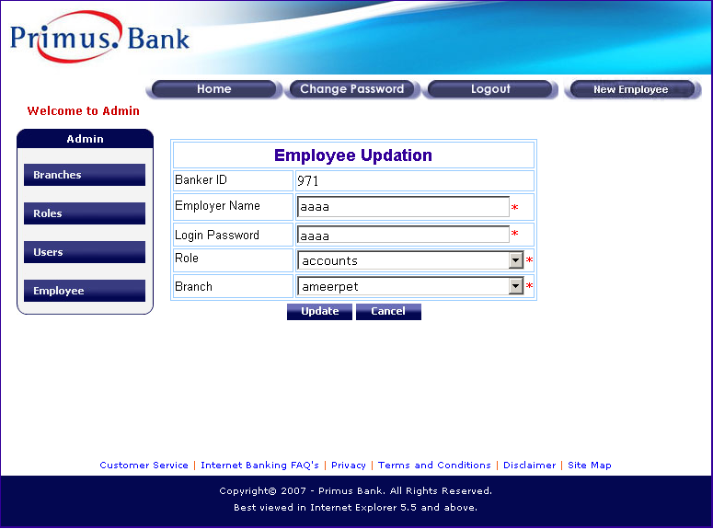

6.3.3 Page Elements
Element Name | Element Type | User Action | System  Response
Banker Id | Auto Display | NA | NA
Banker Name | Text box | Enter/Edit | Accepts
Login Password | Text box | Enter/Edit | Accepts
Role | List box | Select | Displays selected role
Branch | List box | Select | Displays selected role
Update | Button | Click | As per task flow diagram
Cancel | Button | Click | As per task flow diagram

6.3.4 input Validations & Error States

Refer 6.2.4
    - Employee Updation

Actor
Yes
No
Login
Employee
Select required Employee in the Table

Click Edit and update details
Click Update
Employee details are updated successfully
Ask for missing /valid data
Click Cancel
The page is closed
Ok
If modified data is Valid

6.3.6 Use Cases

Admin flow for Edit of Existing Employee Details.
Actors Action | System Response
1. Actor login | 1.System displays Admin module
2. Actor select Employee | 2. System displays Employee details page.
3. Actor click edit on the respective employee details to be edited | 3. System displays Employee Update Page.
4. Update necessary fields with valid data and clicks Update. | 4. System displays a message “Updated Successfully”
5. Update necessary fields with valid data or with out entering any fields clicks Cancel. | 5. System closes the Update Employee details page and displays Employees details page.

6.4 Employee Deletion

6.4.1 Overview

This feature allows admin to delete an unwanted login of PRIMUS bank employee.

6.4.2 Task flow diagram

Actor
Ok
Cancel
Login
Employee
Select required Employee in the Table
Click Delete
Select Ok or Cancel to confirm
The Employee record will be deleted
The employee cannot be deleted
If

Admin flow for Deletion of Employee.
Actors Action | System Response
1. Actor login | 1.System displays Admin module
2. Actor select Employee | 2. System displays Employee details page.
3. Actor click Delete on the respective role to be deleted. | 3. System displays a message “Are you sure you want to delete this record” with “Ok” and “Cancel” buttons
4. Actor Click Ok | 4. System displays a message “Deletion Successfully”
5. Actor Click cancel | 5.System stops the process

